**WEEK -01**

**DESIGN PATTERN AND PRINCIPLES**

* **Exercise 1: Implementing the Singleton Pattern**

🡺CODE:

Logger.java

public class Logger {

    private static Logger instance;

    private Logger() {

    }

    public static Logger getInstance() {

        if (instance == null) {

            instance = new Logger();

        }

        return instance;

    }

    public void log(String msg) {

        System.out.println("log: " + msg);

    }

}

Test.java

public class Test {

    public static void main(String[] args) {

        Logger lg1 = Logger.getInstance();

        Logger lg2 = Logger.getInstance();

        if(lg1 == lg2){

            System.out.println("\nSame instance\n");

        } else {

            System.out.println("\ndifferent instance\n");

        }

        lg1.log("check your inbox\n");

    }

}

**O/P:**

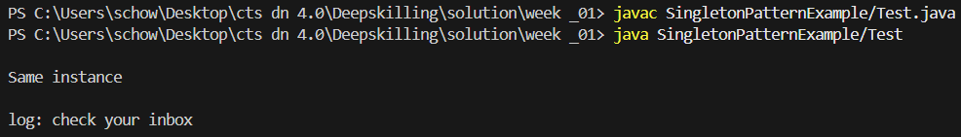

* **Exercise 2: Implementing the Factory Method Pattern**

🡺CODE:

Document.java

public interface Document {

    void open();

    void close();

}

WordDocument.java

public class WordDocument implements Document {

    @Override

    public void open() {

        System.out.println("Word is opening\n");

    }

    @Override

    public void close() {

        System.out.println("Word is closing\n");

    }

}

PdfDocument.java

public class PdfDocument implements Document{

    @Override

    public void open() {

        System.out.println("Pdf is opening\n");

    }

    @Override

    public void close() {

        System.out.println("Pdf is closing\n");

    }

}

ExcelDocument.java

public class ExcelDocument implements Document{

    @Override

    public void open() {

        System.out.println("Excel is opening\n");

    }

    @Override

    public void close() {

        System.out.println("Excel is closing\n");

    }

}

DocumentFactory.java

public abstract class DocumentFactory {

    public abstract Document createDocument();

}

WordDocumentFactory.java

public class WordDocumentFactory extends DocumentFactory {

    @Override

    public Document createDocument(){

        return new WordDocument();

    }

}

PdfDocumentFactory.java

public class PdfDocumentFactory extends DocumentFactory{

    @Override

    public Document createDocument() {

        return new PdfDocument();

    }

}

ExcelDocumentFactory.java

public class ExcelDocumentFactory extends DocumentFactory{

    @Override

    public Document createDocument() {

        return new ExcelDocument();

    }

}

Test.java

public class Test {

    public static void main(String[] args) {

        WordDocumentFactory wordFactory = new WordDocumentFactory();

        Document word = wordFactory.createDocument();

        word.open();

        word.close();

        PdfDocumentFactory pdfFactory = new PdfDocumentFactory();

        Document pdf = pdfFactory.createDocument();

        pdf.open();

        pdf.close();

        ExcelDocumentFactory excelFactory = new ExcelDocumentFactory();

        Document excel = excelFactory.createDocument();

        excel.open();

        excel.close();

    }

}

O/P:

